Tab 1

Army Leadership Development Programme

Notes to the Instructor
Learning isn’t about getting an answer right once. It’s a permanent and consistent change in behaviour, which is resilient to changes in tempo and pressure. We must avoid lecturing and reading material verbatim. This is the “learning vs performance” trap:
- Performance is what an instructor sees during the lesson. A player can mimic a task perfectly and “perform”, but has not learned it.
- Learning is a change over time, applying it consistently after the lesson, and after changes in tempo, pressure and circumstance.

To avoid this, we must consider four aspects to ensure doctrine is learned, not performed:
- Duration, can the player do it after a period of disuse, e.g., three weeks later, and in an operation?
- Adaptability, can the player do it in a new context with changes in tempo, pressure or circumstance, e.g., a section attack can be taught in dry fire, but can they conduct one whilst in contact, receiving casualties, or covertly?
- Consistency, can the player do it repeatably, or was it a fluke?
- Effort, does it still take the player a lot of effort to execute, or is it second nature?

Both at an individual and unit level, you will be able to observe two outcomes of your instruction:
- Lesson identified, they’ve realised what went wrong or how to do it better, but they haven’t changed anything yet.
- Lesson learned, the behaviour on the ground, in different contexts, has actually changed.

To counter this, there are a selection of methodologies available, the first and most pivotal, is the ARCS Model of Motivation, in which lesson delivery is structured as:
- Attention, capturing interest of players at the start, e.g., with a hook or exciting demo).
- Relevance, explicitly stating how this content will keep them alive, make them more effective, or build the best team.
- Confidence, building the players belief in their ability through achievements and milestones.
- Satisfaction, providing a sense of accomplishment at the end of the lesson.

Within the lesson, each piece of content should be delivered through the PAR model:
- Present the information using a variety of media (verbal, visual and physical).
- Apply, give the player the opportunity to use that information immediately.
- Review, a feedback loop, discuss with the player what went well and what didn’t.

To achieve player confidence, you can also follow the following demonstration model:
- I Do, the instructor demonstrates and sets the standard.
- We Do, The instructor and player apply the content together, supporting the player.
- You Do, the player gains confidence in applying the content on their own.

To avoid lecturing or death by powerpoint, you can apply instructional questioning techniques, like:
- Confirmation questions, used at the end of a lesson to ensure everyone has “got it”.
- Open questions, who, what, where, when and why to force the player to explain a concept more deeply.
- Pose-pause-pounce-pound, pose a question, pause to allow thought, pounce on a player for an answer, and pound (support/expand) on the answer received.

Boredom and distraction occurs when the player doesn’t have the instructor's attention. Use concurrent training to keep engagement and learning going. Whilst you focus on a particular player or group, give the other players something to do that benefits their learning, e.g., learning map markers whilst a player is assessed.

Lastly, there are many pitfalls to avoid. Apply self reflection to identify if these are relevant to you:
- Horses for courses, different people are suited to different things, but also learning preferences (visual, auditory or kinesthetic) have been discredited by research.
- Beasting, high-stress training is a staple, but it is in-effective and hinders learning. Expose stress slowly and gradually.
- Passenger effect, players can be physically present, but not engaged or listening. They can provide low-effort answers or repeat answers, but are reactive and nothing is learned. We must ensure all players in the lesson are participative, processing and proactive.
- Dominance, do not allow the lesson to be dominated by a few eager participants, as everyone else becomes passengers.
- Cognitive overload, giving too much information too quickly, overwhelming the player and preventing learning.
- Rite of passage, training is not a test of character, and shouldn’t be miserable. Don’t make training a hardship, or use corrective training as a substitute for teaching.
- Credibility, players learn more if they’re confident in your ability.

Introduction to Leadership
Leadership is the most important factor in the communities success:
- You represent both the community to its players, and the players to the community.
- You are a role model, your conduct and attitude shape our culture, and your players will mimic you.
- You are both your team's friend, and commander.
- You will both motivate, and discipline your friends.

You will find that:
- When an operation goes wrong, you are the first person players will complain to.
- When two players clash, you will mediate their dispute.
- When a player feels down, you may be the shoulder they lean on.
- When a decision is made above you, you are the first person players will question.

And you will be the only person capable of:
- Turning a difficult operation into a fun challenge.
- Be the cool head that restores peace and keeps the group together.
- Protect your players from bullying or harassment.
- Turn decisions into a shared mission that players trust and execute.

Ultimately you will be responsible for growing the community into the place we all want it to be. Rank is not a tool for personal ego or power, instead it is an appointment of service to the community, and the responsibility of its health and players.

So, what do you need to be a good leader?

What is Army Leadership?
Leadership is a combination of three distinct but inter-related elements:
- Command, the authority, responsibility and accountability to issue orders, impress their will on, and transmit intentions to subordinates
- Leadership, the persuasion, compulsion and example that inspires others into action. Anyone can lead.
- Management, the control and allocation of subordinates to achieve results.

Leadership is entwined between the leader and their team. There is not one without the other. The leader must have an intimate understanding of their team in order to motivate.

Leadership Ethos
The Army leadership code is a collection of proven behaviours that excellent leaders at all levels embody, remembered by the mnemonic LEADERS:
- Lead by example
- Encourage thinking
- Apply reward and discipline
- Demand high performance
- Encourage confidence in the team
- Recognise individual strengths and weaknesses
- Strive for team goals

This is underpinned by a collection of values and standards, notably our community values, the Army values, and the Army standards, all which a leader should represent, adhere to and reflect regularly on:

Community Values
- Emotional Intelligence is understanding your own emotions and those of others, staying calm under pressure, reading the room, and building people up instead of breaking them down. That means:
  - Knowing when to lead and when to follow.
  - Taking ownership without blame.
  - Addressing issues.
  - Not being disruptive to others.
- Intellectual Humility is the ability to admit you might be wrong and valuing learning over being right. That means:
  - Giving constructive feedback without ego.
  - Asking questions before assuming.
  - Being open to feedback, even if it stings.
  - Acknowledging gaps in your own knowledge.
British Army Values | British Army Standards
- Courage is doing the right thing, even when it's hard.  - Discipline is self-control, following orders and giving others trust.  - Respect is treating everyone with dignity.  - Integrity is being honest and taking responsibility.  - Loyalty is backing each other and the community, in-game and out.  - Selfless Commitment is putting the community before yourself. | - Lawfulness is adhering to community rules, and whilst in-game, the Law of Armed Conflict and Rules of Engagement.  - Acceptable Behaviour is the promotion of team spirit and respect, and the rejection of bullying, harassment, or misconduct.  - Professionalism is a consistent commitment to competence, skill, and application of the values and standards.

Servant Leadership
If you are above serving, you are below leading. The Army leadership approach is to reverse the traditional view on leadership, and instead think about how you can support your team in doing their best. This means understanding their needs, strengths and weaknesses, and empowering them to do great things.
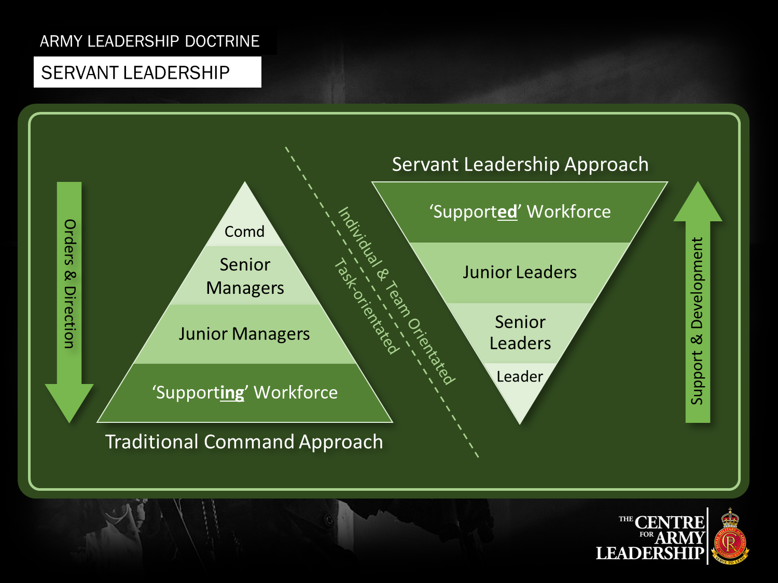

Discipline and Development
Leadership can almost be equated to parenting, however one must not underestimate or undervalue their subordinates. Much like parenting there will come a time where your subordinate’s behaviour must be corrected, and it falls upon leadership to be professional and fair about how the situation is dealt with, treat misbehaving subordinates with respect. A good axiom to stick to is:
“Praise in public, Bollock in private”

Always remember to reinforce desirable behaviour as well, bad Leadership only sees the shortcomings of their subordinates, give them a reason to want to be better.

If and when a subordinate displays undesirable behaviour and refuses to correct it, that member must be removed, negativity spreads quickly and can turn the environment toxic without you even noticing.

Leadership should be confident about their decisions, while incorporating feedback, avoid unilateral decisions but understand, you have the final say.

ICs can often tunnel vision, remember you're usually not alone out there and can always fall back on the Company, also remember you can make use of non-organic assets* with permission from 0

What makes leaders good and bad?
Good leaders have | Bad leaders have
Knowledge  Skills  Experience  Humility  Humor  Confidence | Negativity  Selfishness  Inappropriate Behaviour  Toxicity  Autocracy

10 diseases of leadership
Lacks moral Courage
Leaders fail to do the right thing even when they know they should.

Failure to recognise that opposition can be loyal
Challenge from subordinates are valuable. It takes a significant amount of moral courage to challenge someone in a leadership position. If this behaviour is encouraged, it promotes a culture of healthy challenge. If it is discouraged, people will not share their concerns or offer ideas for improvement.

Consent and Evade
Leaders openly agree with the plan but secretly they are unconvinced. They then don’t play their part in supporting the implementation of the plan. This breeds misalignment throughout the organisation.

‘You don’t need to know that…’
Information is power. Some leaders will try to reinforce their position by holding onto information unnecessarily. This reduces the ability for their subordinates to be able to act on their initiative because they lack the wider situational context.

Refusal of Facts
Leaders lack flexibility and are determined to drive through their plans regardless of new information or a change in circumstances. Michael Gove proved to be a good example of this when he said ‘Brits have had enough from the experts’.

Analysis Paralysis
Leaders delay making decisions because they are waiting for more information which in reality might not come. Often described as ‘analysis paralysis’, the inability to make decisions means subordinates cannot act.

Equating the quality of advice with someone’s position or experience
Wisdom and insight are not necessarily connected to experience or position. Sometimes the least experienced person or someone outside the team can offer the freshest perspective on a problem. These people can be ignored by leaders who over-value experience and positional authority.

I’m too busy to win
Leaders are so focussed on executing the current plan and/or routine business that they fail to identify and exploit opportunities that might increase their chances of success. When a leader is so focussed on what they’re doing, they’re unable to ‘stick their heads up’ and look for better ways or opportunities in which they might be able to complete their plan faster and more efficiently.

‘I can do your job better than you can…’
Leaders who readily drop into their comfort zone and micro-manage subordinate leaders. They might have done the job previously and assume that they can do it better than the person currently in the role. This is particularly common in sales teams where a sales leader will often work hard to make up the shortfall in a team target rather than coaching and developing their people to hit the target.

Big man, cold shadow
Leaders might appear successful to those outside the team but are actually responsible for creating a negative climate within the teams they lead.

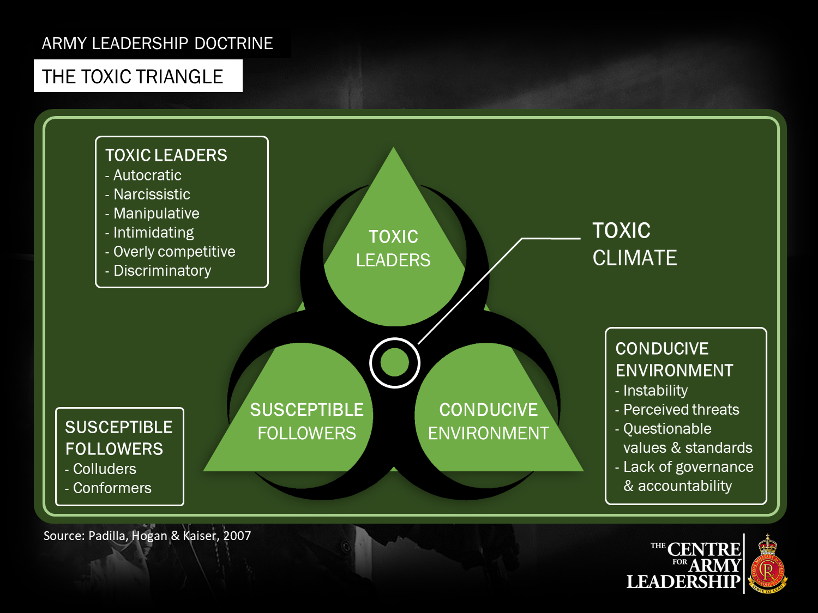

Manueverist Approach
Text

Mission Command
Text

Tempo and the OODA loop
Tempo wins wars. Tempo is your battle rhythm and speed of good action, relative to your enemies. Good tempo can create an advantage against unwinnable odds. Rushing isn't the same as having a good tempo.

Our tempo, at all levels, must be faster than our enemies. The OODA loop represents how quickly you receive information and make good decisions:
- Observe and receive good or bad information about the situation, environment, opportunities and threats.
- Orient yourself in the context of the information and your surroundings by conducting a combat estimate.
- Decide and plan the best course of action
- Act and execute your plan, either successfully or unsuccessfully.

Poor information, panicked orientation and poor planning reduce your chances to act successfully. If you act unsuccessfully, you slow down your own tempo, and increase your enemies tempo.

This table shows some of the methods you can modify your tempo, and your enemy tempo through successful execution.

Friendly tempo = 5 minutes | Enemy tempo = 2 minutes
+ info about your enemy positions and movements  + info about ammunition and casualty  + good positioning, no over exposure  + calm planning  - prolonged, uncertain engagement  - poor communication of the plan  - poor consideration of surroundings | + info about your positions  + info about your movements  + info about your intent  + concealment of own intention  + surprise  - hitting traps and ambushes  - being detected too early  - poor info about your capabilities
+ increase tempo. - reduces tempo

This table shows a real example of how to modify tempo based on the OODA loop.
Friendly tempo < enemy tempo | Friendly tempo > enemy tempo
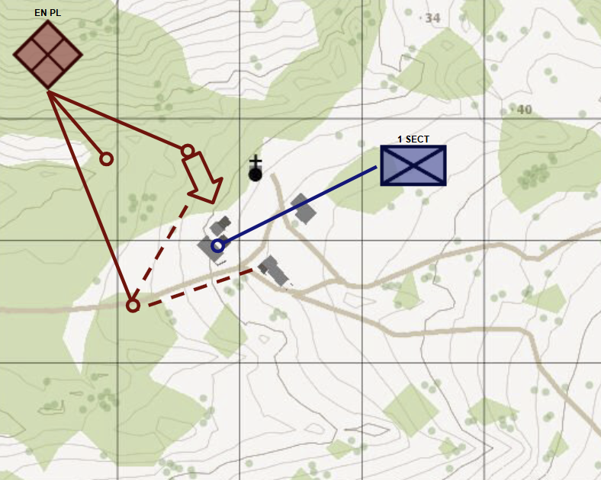 | 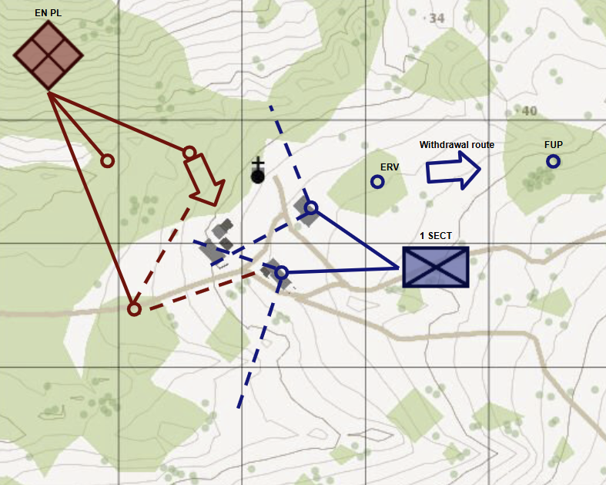
1 SECT doesn’t follow the OODA loop prior to occupying the town. | 1 SECT follows OODA loop to occupy the town, and react to contact.
- close distance to enemy concealment, reducing OODA time  - charlie and delta team fixable in same position, reducing orientation and planning options | + distance from enemy concealment, increasing OODA time  + harder to spot by enemy, reducing enemy OODA time  + better arcs of fire for spotting enemies  + separated fire positions increase orientation and planning options  + pre-planned withdrawal in case overwhelmed

No fight is planned to be fair. By staying calm, and managing your OODA loop, you can ensure your tempo is quicker than your enemies, allowing you to succeed or survive overwhelming odds. Failing to plan, is planning to fail.

Combat Estimate - The Seven Questions
The combat estimate allows you to orient as part of the OODA loop - interpret the information available to inform the best course of action.

Q1 | What is the enemy doing, with what, and why? | Identify what’s evident close, and what’s in depth, of the enemy:  - Strength  - Weapons  - Arcs  - Tactics  - Type of position  - Intent
Q2 | What have I been told to do and why? | What’s my mission and commander's intent?
Q3 | What effects do I want to have on the enemy? | What is my intent? Destroy, suppress, stop, find etc.
Q4 | Where and how can I best carry out each action / effect? | Analyse the ground for:  - Obstacles  - Cover and concealment  - Observations, fields of fire  - Key terrain  - Avenues of approach and withdrawal
Q5 | What resources do I need for each effect? | Who is best placed or equipped to do it? Do I need additional support?
Q6 | When and where do the actions take place in relation to each other? | What different things need to happen and when, from QBO to finish.
Q7 | What are the control measures? | What could go wrong, and how will you avoid it? Boundaries, arcs, actions on.

Tactical Framework
Find, fix, strike, exploit

Geographical Framework
Deep, close, rear

Principle of four
Recce/Fixing Four
Striking/Manoeuvre Force
Echelon Force
Uncommitted Reserve Force

Section Drills
Basic section lineup

A Standard infantry Section is made up of 8 members and are separated into 2 Fireteams, Charlie and Delta, which have 2 distinct roles.

Charlie is the Maneuver fireteam

Delta is the Fire Support fireteam

As standard, an infantry section will be set up as follows:

Charlie:
- Section Commander
- Pointman/Breacher
- Grenadier
- AT
Delta:
- Team Leader/2IC
- Gunner
- Medic
- Sharpshooter

Though this is the standard, some deviation, if correctly justified, can exist. It is up to the IC to set up his section BEFORE stepoff.

- Section Battle Drills

The Section Battle Drills are what dictate the several stages of an operation, think of it as a loop that you go through every engagement. The Battle Drills can be remembered through the mnemonic PRESAR:

P- Prepare for Battle
R- React to Effective Enemy Fire
E- Enemy (find them)
S- Suppress the Enemy
A- Attack/ Assault
R- Regroup/ Reorganise

Each of these Battle drills have their own drills within them which we will cover one by one.

Prepare for Battle

This Battle drill has the mnemonic PAWPERSO within it:

P- Protection
A- Ammunition
W- Weapons
P- Personal Camouflage
E- Equipment
R- Radios
S- Specialist equipment
O- Orders

Prepare for Battle is mainly about making sure everything is squared away before step off. As leadership your job is to make sure everyone in your section has done their PAWPERSOs and to adjust their kit as needed.

As an IC you must also ensure you have your orders and to make your own planning. You should at least have a rough idea of what is going to happen. In briefing, an overview plan is usually discussed but more often than not its missing vital details. For example “1-1 you will be assaulting this position”, the IC now has to figure out exactly how to perform that task, IC’s should then perform their own briefings to their section.

Notes on Briefings:

- The goal of the section brief is to digest the platoon level brief into simple and easy to understand orders for your section, and present them with the information relevant to them. When giving briefings use doctrinal verbs for clarity.

- In order to make sure your subordinates understand your briefing it's common practice to ask them questions individually about their tasking.

- It is also recommended to use IRL notepads (though digital notepads work as well).
- 5RB J2 Generic Orders

React to Effective Enemy Fire

This one is fairly straightforward, every member of the section should know this off by heart, this is your basic RTR drill.

R- Return fire
T- Take Cover
R- Return Accurate fire

As Leadership it's important you understand that this also scales up to the whole section and isn't just an individual skill. In times of high stress you must drive your section to perform these tasks when they are not able to do these themselves.

Enemy (find them)

When in contact and still on the take cover phase of your RTR, you'll need to locate the enemy in order to properly engage them. To this extent there are some fundamental things to look for.

Silhouettes are very useful to find enemies with sloppy positioning, someone who is positioned in front of a bright background, snow, bright green grass, walls and even the sky are dead giveaways. Avoid placing your section in these places.

Sudden movement is also a good indicator, look through bushes, do you see movement within them? Take a good long look with these as it will be hard to spot even if its right in front of you

Sound is extremely important to locating the direction of contact, for this you'll need to understand 2 things

1- Bullets travel faster than the speed of sound
2- You never hear the gun firing before you get hit

Knowing these things we can locate the enemy by standing still, as shots pass over our cover we listen for the crack of the round going over us, and then we hear a small pop, that pop is the sound of the gun firing and is the direction of the contact. Now you can observe if there is smoke or dust kicking up, scan high and low as the enemy may be higher up than you think.

Suppress the Enemy

Now that we have figured out where the enemy is we can try to get the most important part of any engagement, Fire Superiority. For this we will need to issue some orders, namely we need the DDD, so the section knows where the enemy is, as well as an FCO (Fire Control Order).

D- Direction
D- Distance
D- Description

With the DDD being given by the IC or a section member, the IC can now call an FCO.

FCO’s are a way to control the ammo output of the section and provide suppressive or accurate fire when needed.

An FCO is given through the mnemonic GRIT

- Group - Who am i addressing
- Range - Range to target
- Indication - Target description/direction
- Type of fire - Rapid, Deliberate etc.

The different types of fire are
- Rapid - 1 shot every 2-3 seconds
- Deliberate - 1 shot every 4-5 seconds
- Watch and shoot - fire only at visible targets
- Hold Fire - Stop shooting

There are also multiple Types of FCO
- Full - We are giving the full GRIT
- Brief - We are giving a cut down version of GRIT
- Individual - We are addressing a single section member
- Delayed - We are queueing the FCO on an order ex. “Section, on “excecute” 150m, NW, Rapid fire”

Attack/ Assault

This is the main part of the engagement, remember that There is No Movement Without Fire (or at least the capability of fire) so make sure you have fire superiority before trying to assault, if you cannot get it, consider pulling back to reposition or attack with another section.

There are multiple kinds of assault which will be explained in further detail later in the document, for now know that there are:

- Flanking assaults
- Direct assaults

Regroup/ Reorganise

This is the last phase of your battle drills and it's all about getting back together and understanding the current state of the section and what's needed before next tasking. After regrouping we need to figure out if the section needs ressupply, to do so we can use either ACE checks or CASAMM checks.

A- Ammo
C- Casualty
E- Equipment

CASAMM is largely the same as ACE just without the Equipment part. In order to collect an ACE check, call out member by member and collect their ace report, this is to ensure we collect the information cleanly.

If we do identify that we need resupply we can then send a resupply request to 0-C following the resupply request slate.

It is important that while resupplying we maintain security, as such it is standard that a section resupply by fireteam, as coordinated by the section IC, or in case of multiple section resupplying, by section with coordination from 0

When resupplying we will use the mnemonic PACESDDO:
P- Protection
A- Ammunition
C- Casualties
E- Equipment
S- Searchers
S- Sitrep
D- Dig in
D- Deploy
O- Orders

- Formations and How to use themRAM

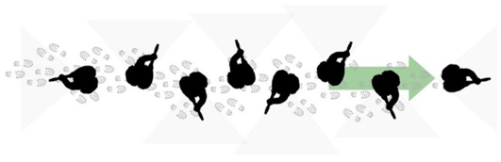

Single File

Fairly straight forward formation, ideal for moving larger distances while maintaining command and control of the troops, in a single file, only the first man should be looking forward, the rest should take alternating sides, with the last man looking rear, there are referred to as their Arcs of Fire

This is not a formation from which to fight from, when reacting to contact, or expecting to meet contact, change to a different, more appropriate formation.

Arrowhead

A very good formation for advancing to contact as it allows maximum frontal firepower, a good section can even coordinate to stagger the “wings” allowing each man to fire through the formation. Arcs of Fire should be to the side and front, forming a 90º Arc in front of the formation
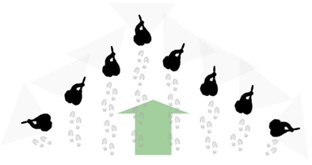

Extended Line / Baseline

This is a very simple formation but its also the most useful as it maximises the amount of outgoing fire while reducing the side profile of the section, this formation serves as the basis of the simple section attacks and flanks we will look at later on.
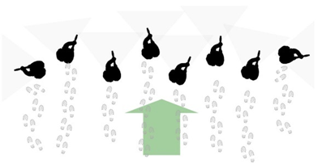

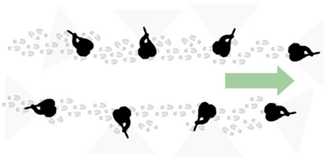
Staggered File / File

This formation is made to take advantage of roads, rivers, terrain lines and bridges, it spreads the section on opposite sides of the road, maintaining gaps between personnel to allow for firing through the formation, this increases the amount of available outgoing firepower as well as guarding against IEDs and mines. Arcs of Fire work exactly like they do in a Single File.

Some notes on Arcs of Fire: As you can probably see all of the arcs go outwards from the section, this is to prevent accidental friendly fire, however Arcs switch inwards when in towns to maximise sightlines.

All Around Defense / ARD

This formation is intended to provide security in short to medium stops, where infantry fan out and provide security. This serves to create space for an IC which may want to sit in the “safe zone” and perform planning or other tasks.
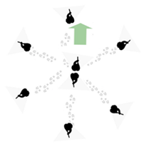

- Basics of Section Movement

When moving its useful to remember your formations, however that all changes when we enter potential kill-zones or are in contact, in these instances we make use of maneuvers such as:

- Bounding
- Leapfrogging
- Peeling

Bounding

Mainly used when moving across large pieces of terrain with little to no cover, or when we have to close the gap while in contact.

Bounding can be done wherever there are at least 2 elements and can be scaled up, you can bound with 2 men, 2 fireteams, 2 platoons, it's a very universally useful maneuver.

Leapfrogging

Works exactly the same as Bounding, the difference is each fireteam moves PAST the other one and secures their own new base of fire

Peeling
Used when the section needs to move laterally while in a firefight, fire is kept up at all times.

Notes on maneuvering: Remember that there is no movement without fire

- Section Attack

Section attacks showcase the fundamentals of an assault. When planning an attack, be it as a section or as a platoon, there should also be at least 2 elements, a Fire Support element and an Assaulting element, though ideally you have a third element as reserve as well.

At the section level, in order to perform an assault we must make sure to first, locate the enemy as per our PRESAR and then obtain Fire Superiority to allow for movement. Once ready, the section bounds forward, always maintaining fire, until they are close enough to use grenades. While on their approach the IC calls for Delta to Swing Fire to avoid Blue on Blue, once in position, Charlie throws grenades and upon successful detonation, they move in to clear.

Section Flanks are preferably also sprung from a baseline formation, a section flank will start with charlie moving away from delta while they put down suppression, charlie then moved through concealment and arrives into a position where they can see the enemy, they call for delta to swing fire and spring their attack by throwing grenades and moving in to clear.
As per PRESAR the section then regroups and performs their PACESSDDO.

- Main Tasking Types

This section is a list of different taskings you may be assigned.

Assault

Assaults are essentially the main attack, the goal is to get into the enemy position and clear it, it can be done with a section flank as it only denotes effect and intent.

Support by fire (SBF)

SBF are taskings with the intent to provide other groups with support from range, the marker does not indicate a specific position and IC’s are free to place the position where they see fit according to terrain.

Follow and Assume

Follow and assume are support taskings, your goal is to trail behind another section and support when asked to, if the forward section gets into trouble the following section takes over tasking and continues on, maintaining the momentum of the assault.

Block

Blocks are taskings where the intent is to restrict or stop enemy movement through an area, they can be used to isolate objectives or protect against QRF, these are largely defensive postures.

- ORBAT Structure

As an IC it is imperative that you know who will be with you on the field. Lets go over all the different assets, their callsigns and their capabilities.

- C COY (0)
  - Responsible for running the platoon
  - Creates planning and conducts O Group* Brief
  - Manages the section’s needs
  - 0 contains the R group, which is made up of:
    - 0-A (OC)
      - Overall Commander, responsible for the Company and planning
    - 0-B (Company 2IC)
      - 2IC of the Company, assists 0-A
      - Generally responsible for fire support assets
    - 0-C (CSM)
      - Responsible for secondary elements
      - Generally responsible for Resupply and Logistic support
      - Typically handles the morale and standards of the troops

- 1, 2, 3 Sec (1-1, 1-2, 1-3)
  - Main infantry forces
  - Perform ground level tasking as issued by C Coy
  - Have internal APC for transport

- RAMC (5-1)
  - Attached medical element
  - Responsible for manning and creating CCP’s
  - Responds to sections in need of emergency medical assistance

- ELS (4-1)
  - Logistical element
  - Perform resupply of sections and vehicles
  - Perform controlled detonations
  - Perform Demining and bridge laying
  - May reinforce positions with static weapons systems and HESCO

- JAC(R) (6-1)
  - Rotary wing unit
  - Respond to CAS/CCA requests
  - Perform ISTAR
  - Perform Logistics

- RAC (2-1, 2-2)
  - Armour crews of the unit
  - Able to crew MBT’s, IFV’s and SPAA’s
  - Conduct Recce
  - Provide fire support
- FSG (3-1)
  - Fire support Group
  - Gun teams focused on shaping operations
  - Capable of isolating objectives
  - Have access to heavy AT, MANPAD launchers and mortars

O Group is the “Orders Group” which includes all commanders and 2IC’s of the Company*

ALDP V2
# 5 RANGER — Advanced Leadership Development Programme (ALDP)
### Version 2.0 — Refined British Edition
*"Lead Quietly, Strike Hard."*

> All original 5 RANGER doctrine preserved verbatim.
> Expanded with FM 3-90 (Mission Command), the British Cadet Fieldcraft Manual, and British military thought from Corbett, Slim, and Mayne.
> Tone: British brevity — professional, understated, and direct.

---

## 0.0 Instructor Guidance

This manual is both a **doctrinal text** and a **teaching guide**.
It is to be taught using the walk–talk–run method common to British training:

1. **Walk** — Explain the principle.
2. **Talk** — Have the students verbalise and question it.
3. **Run** — Execute it under simulated or live conditions.

Every Ranger, regardless of experience, should be able to teach what they know and learn from those below them. Leadership is taught by habit and proven by pressure.

### Timings
| Period | Topic | Duration |
|:--------|:-------|:----------|
| Opening & Ethos | 0.5 hr |
| PRESAR & Section Battle Drills | 1.0 hr |
| Leadership & Morale | 0.5 hr |
| Platoon & Combined-Arms Integration | 1.0 hr |
| Assessment & Review | 0.5 hr |

### Instructor Notes
- Reinforce **CDRILS** at every phase.
- Promote participation — every Ranger should speak before the end of a session.
- Confidence is more important than flawless answers.
- Keep humour dry and purposeful; banter is not morale, but it helps build it.

[Image Placeholder: Training Cycle — Walk/Talk/Run diagram]

---

## 1.0 Course Intent & Overview

The aim of this manual is to provide a comprehensive framework for leadership, tactics, and instruction within 5 RANGER. It teaches not only how to command effectively but also how to embody the values that define the Regiment.

### 1.1 What is a WARNORD (Warning Order) and how to use it
A **WARNORD** (Warning Order) is an early alert from higher command that a mission is forming. It gives subordinate leaders time to prepare before receiving full orders.
A well-issued WARNORD saves lives and builds tempo.

**Contents of a WARNORD:**
- **Who:** Higher HQ or issuing unit.
- **What:** Operation type or expected task.
- **When:** Approximate time or trigger.
- **Where:** General area or objective.
- **Why:** Intent or mission purpose.
- **Initial tasks/constraints:** Immediate preparations.

**How to plan around a WARNORD:**
1. **Immediate prep:** Conduct PAWPERSO and comms checks.
2. **Sketch a plan:** Use the TLP Quick Card.
3. **Recon:** Send a scout, drone, or visual sweep to confirm unknowns.
4. **Relay:** Pass simplified WARNORDs down to fireteams.
5. **Time discipline:** All planning should be timeboxed; action beats perfection.

### 1.2 What recon looks like at section level
Reconnaissance is deliberate curiosity. It is not wandering — it’s directed information gathering to confirm or deny assumptions.

**Types:**
- **Dismounted:** Low signature, stealthy eyes-on confirmation.
- **Mounted:** Fast, route or obstacle checks.
- **Technical:** Drone or optical use for standoff.
- **Map & terrain:** Identify dead ground, choke points, and cover.
- **Bounding recon:** Use fireteam overwatch to “probe” ahead safely.

**Key Recon Questions:**
1. Where is the enemy likely to be?
2. Where can we move with cover and concealment?
3. What terrain will kill us first if we’re wrong?

### 1.3 How to assemble orders
Orders are communication, not paperwork. They translate thought into unified action.

**6-Line Section Brief (preferred for 5 RANGER):**
1. **SITUATION:** Enemy, friendlies, terrain.
2. **MISSION:** Who, what, where, when, why.
3. **EXECUTION:** Concept, manoeuvre sequence, timings.
4. **SERVICE & SUPPORT:** Resupply, med, ammo.
5. **COMMAND & SIGNAL:** Nets, call signs, chain of command.
6. **CONTINGENCY:** “If X, then Y” actions.

**SMEAC (for instruction or extended briefs):**
- Situation
- Mission
- Execution
- Administration & Logistics
- Command & Signal

**Tips:**
- State the intent first; tasks come second.
- Use triggers (“On my signal,” “At 0600,” “When Delta sets”).
- Require readbacks to ensure clarity.

**Example WARNORD:**
> “1-1 WARNING: Probable raid on north farm grid 013020 in 0400. Prepare PAWPERSO, comms check on net Blue, one-hour notice. Recon teams to check west approaches. More to follow.”

**Example 6-Line:**
1. **Situation:** Enemy patrol north ridge; friendlies east.
2. **Mission:** 1-1 seizes north farm 013020 by 0400 to deny enemy observation.
3. **Execution:** Charlie bounds, Delta SBF; main effort Charlie.
4. **Service & Support:** Resupply at Road X; RAMC 011015.
5. **Command & Signal:** IC Net Blue; 2IC assumes if IC down.
6. **Contingency:** If armour appears, withdraw to Rally A.

### 1.4 Historical Notes on the Quoted Figures
- **Julian Corbett (1854–1922):** British naval historian; wrote *Some Principles of Maritime Strategy* (1911), which defines war as the continuation of policy — fighting is only a means to peace.
- **Field Marshal William Slim (1891–1970):** Commander of the 14th Army in Burma; author of *Defeat into Victory* (1956). Known for humility, discipline, and morale-building leadership.
- **Lt. Col. Robert “Paddy” Mayne (1915–1955):** SAS founder and decorated leader; exemplified the balance between aggression and loyalty.

### Doctrinal Expansion (FM 3-90 / Corbett)
*Corbett wrote:*
> “The object of war is not fighting, but to obtain a better state of peace.”
That sentiment lies at the heart of 5 RANGER command philosophy: violence must always be intelligent, never indulgent. The section IC fights for purpose, not pride.
Mission Command empowers initiative, trust, and disciplined disobedience in pursuit of intent.

**TLP Quick Card:** Receive → WARNORD → Plan → Recon → Orders → Rehearse → Execute.

### Instructor Note
Run a short WARNORD drill:
1. Issue a two-line WARNORD.
2. ICs sketch a COA.
3. Conduct quick recon with markers or drones.
4. Issue a 6-line order.

### Assessment (Game-ified)
*“WARNORD Hustle”* — IC receives WARNORD, issues COA + 6-line brief + recon task in under 3 minutes. Scored for tempo and clarity.

---

## 2.0 Ethics & Code of Conduct

Being a Section IC bears responsibility as well as authority. If an operation fails, criticism comes to you first; if it succeeds, you share credit with the team. You are the first point of contact for your soldiers and must handle questions and complaints professionally.

Leadership is management as well as command. Leaders become role models; their behaviour is mimicked by subordinates.

**Maxim:** “Praise in public, bollock in private.”

Reinforce good behaviour as actively as you correct poor behaviour. Persistent negativity must be removed before it infects the section.

**CDRILS Values:** Courage • Discipline • Respect • Integrity • Loyalty • Selfless Commitment.
**Good Leaders:** Knowledge • Skill • Experience • Humility • Humour • Confidence.
**Bad Leaders:** Negativity • Selfishness • Inappropriate Behaviour • Toxicity • Autocracy.

[Image Placeholder: CDRILS values poster with icons]

### Doctrinal Expansion (FM 3-90 / Slim)
*Slim wrote in Defeat Into Victory (1956):*
> “The only real test of a leader is when things go wrong.”
Ethics under pressure is the measure of character.
**Emotional Intelligence (EI)** supports CDRILS:
- **Courage:** Stay calm under fear; control tone and timing.
- **Respect:** Listen before judging.
- **Integrity:** Match words to actions.
- **Loyalty:** Uphold team decisions even under doubt.
- **Discipline:** Manage emotion; lead with composure.

### Instructor Note
Pose a dilemma: “A Ranger refuses an order he thinks unethical. What do you do?”
Let the group debate; don’t hand them the ‘right’ answer.

### Assessment (Game-ified)
*“CDRILS Card Pull”* — Draw one value; give an Arma-accurate example of that value under fire.

---

## 2.5 Battlefield Judgement & OODA Loop

Decision-making is the true art of leadership. The OODA loop — **Observe, Orient, Decide, Act** — keeps command alive even when plans break down.

### Doctrinal Expansion (FM 3-90 / Slim)
*Slim observed:*
> “The art of command is to be right enough, soon enough.”
Perfect decisions are rare; timely, reasoned action wins.
The OODA loop ensures tempo and adaptability.

**OODA Applied:**
1. **Observe:** Collect facts from reports and senses.
2. **Orient:** Interpret terrain and enemy behaviour.
3. **Decide:** Choose the simplest effective action.
4. **Act:** Execute swiftly, adjust as information changes.

### Instructor Note
Simulate limited information scenarios. Have ICs commit within seconds, then review outcomes.

### Assessment (Game-ified)
*“Snap COA”* — IC must issue a concise plan within 5 seconds of contact. Clarity beats detail.

---

## 3.0 Diseases of Leadership (Expanded)

Historian **Richard Holmes** identified ten recurring failures in command. Below, each “disease” includes a symptom and its emotional-intelligence countermeasure.

| Disease | Symptom | Countermeasure |
|:--|:--|:--|
| Moral Cowardice | Avoiding hard truths | Speak first when silence costs lives. |
| Ignoring Opposition | Shutting down ideas | Hear one dissenting voice per plan. |
| Consent & Evade | Agreeing then avoiding | Dissent early; obey fully once decided. |
| Withholding Information | Hoarding control | Share mission context, not just orders. |
| Refusing Facts | Ego over evidence | Seek one external confirmation before acting. |
| Analysis Paralysis | Overthinking | Apply the 70% rule: act when mostly informed. |
| Rank Equals Truth | Arrogance | Invite feedback from subordinates. |
| Tunnel Vision | Narrow focus | Appoint an observer to “watch your flanks.” |
| Micro-management | Fear of failure | Set intent and boundaries, not step-by-step tasks. |
| Big Man, Cold Shadow | Intimidation | Lead with humour and humility. |

*Lt. Col. Robert “Paddy” Mayne*, founder of the SAS, embodied decisive aggression without cruelty. His command style showed that audacity, tempered by loyalty, earns respect faster than rank.

### Instructor Note
Assign teams to act out each disease during an in-game scenario, then rerun the same scene corrected.

### Assessment (Game-ified)
*“Name & Fix”* — Instructor names a leadership flaw; IC states a countermeasure within 10 seconds.

---

## 4.0 Basic Section Line-Up

A standard infantry section consists of eight members split into two fireteams.

**Charlie (Manoeuvre):** IC • Point/Breacher • Grenadier • AT
**Delta (Fire Support):** 2IC • Machine Gunner • Medic • Sharpshooter

IC sets section structure before step-off; deviations allowed with reason.

[Image Placeholder: Section layout diagram — Charlie/Delta roles]

### Doctrinal Expansion (FM 3-90 / Cadet)
Every man must know two roles — his own and the one above. Resilience lies in redundancy.

### Instructor Note
Use a table-top sand model. Each Ranger describes their job and its link to the next.

### Assessment (Game-ified)
*“Snap Task Org”* — Instructor changes mission; IC has 30 seconds to reassign roles.

---

## 5.0 Section Battle Drills (PRESAR)

**PRESAR:** Prepare • React • Enemy • Suppress • Attack • Regroup.

Each phase has sub-drills:

**Prepare — PAWPERSO:** Protection • Ammo • Weapons • Personal cam • Equipment • Radios • Specialist • Orders.
IC ensures completeness and conducts own planning and brief.

**React to Fire (RTR):** Return • Take Cover • Return Accurate Fire.
Scale RTR to section level; drive your team through under stress.

**Enemy (Finding):** Observe silhouettes, movement, sound (crack-pop), dust.
Teach new leaders to interpret contact clues.

**Suppress:** Use DDD (Direction, Distance, Description) and FCO (Fire Control Orders). Manage ammo and assign SBF.

**Attack:** Gain fire superiority before movement. Flank when direct assault fails. “No movement without fire.”

**Regroup:** Conduct ACE/CASAMM checks and resupply via 0-C by fireteam. Maintain security.

[Image Placeholder: PRESAR loop diagram]

### Doctrinal Expansion (FM 3-90 / Cadet / Corbett)
Corbett observed that “war is movement and perception.”
Teach PRESAR transitions as rhythm — action without pause.
Walk, talk, run until timing feels instinctive.

### Instructor Note
Run “PRESAR Chain” drills: call random stage transitions; section must respond instantly.

### Assessment (Game-ified)
*“PRESAR Run”* — Full sequence executed under simulated fire in <2 minutes.

---

## 6.0 Formations & Usage

**Column/Single File:** best for long movement.
**Arrowhead/Wedge:** best for advancing to contact.
**Line/Baseline:** max firepower on assault.
**Staggered Column:** roads or IED threat.
Echelons not used.

[Image Placeholder: Formation cheat sheet — Column/Wedge/Line/Staggered]

### Doctrinal Expansion (Cadet)
Formations are a language. Every spacing and angle communicates intent.
Start static, progress to dynamic, add fire control last.

### Instructor Note
Rotate formation drills by whistle, radio, and hand signal. Grade reaction time.

### Assessment (Game-ified)
*“Call & Form”* — Instructor names terrain; section forms correct formation in <10 seconds.

---

## 7.0 Section Movement Basics

**Bounding:** Alternating fireteams leapfrog under covering fire.
Steps: Baseline → “Prepare to bound” → “BOUND” → “Charlie set” → “Delta BOUND.”

**Leapfrogging:** Each team passes the other to extend advance.

**Peeling:** Controlled withdrawal; each man passes behind and calls “last man.”

**Principle:** No movement without fire.

[Image Placeholder: Bounding and Peeling sequence diagram]

### Doctrinal Expansion (FM 3-90 / Slim)
*Slim wrote:*
> “Get the men on their feet and moving — movement is life.”
Movement connects firepower to intent. Teach leaders to exploit terrain — Hard cover, Soft cover, Concealment.
A good IC moves deliberately; a great one moves rhythmically.

### Instructor Note
Alternate fireteam leaders on each bound. Penalise overexposure and hesitation equally.

### Assessment (Game-ified)
*“Two-Hop Bound”* — Two successive bounds to objective marker with perfect timing.

---

## 7.5 Platoon-Level Control & Command Bridges

A section leader must be fluent in the handover between section and platoon. Platoon-level control is the domain where intent becomes choreographed manoeuvre; the section leader must both receive intent and translate it downward cleanly.

### Doctrinal Expansion (FM 3-90)
Platoon-level control depends on shared understanding and delegated authority. The platoon commander sets intent and the main effort; sections provide tempo and feedback. Synchronise fires and movement with company assets and maintain liaison with adjacent sections to prevent fragmentation of effort.

### Instructor Note
Teach a simple handover script:
- Platoon intent (one sentence)
- Main effort (who & why)
- Timings & triggers (absolute and relative)
- Support/resupply windows
Practice passing the handover in 60 seconds, then execute a 2x section handover in an exercise.

### Assessment (Game-ified)
*“Relay Drill”* — Two sections execute a handover and continue a mission; scoring is based on tempo and clarity (no lost actions).

---

## 8.0 Section Attack / Flank (Expanded)

Attacks at section level must be brutal in simplicity and precise in timing. Identify decisive points, suppress to fix, then move to finish. Swing-fire and grenade windows control spacing and prevent fratricide.

### Doctrinal Expansion (FM 3-90)
Tactical assaults follow a simple flow: find, fix, finish, follow-through. Even at small-unit scale, synchronisation between suppressive elements and manoeuvre is combined-arms in miniature — integrate fires, manoeuvre and engineer effects where available.

### Instructor Note
Build a progressive attack lane on the range or in Arma: SBF positions, approach corridor, grenade range, assault line. Run rehearsals until cadence is consistent across teams.

### Assessment (Game-ified)
*“Green Light Grenade”* — Team performs swing-fire and simulated grenade employment: first pass must be clean (timing & spacing).

---

## 9.0 Main Tasking Types (Clarified)

Taskings must be simple, with an obvious main effort and a clear trigger.

- **Assault:** Seize/clear objective.
- **SBF:** Suppress to allow manoeuvre.
- **Follow & Assume:** Trail, then take lead if required.
- **Block/Delay:** Deny or slow enemy movement.
- **Screen/Protect:** Observe and warn the higher echelon.

### Doctrinal Expansion (FM 3-90)
Taskings scale — the same verbs apply up the chain. Teach leaders to visualise the platoon fight and articulate how their section achieves the commander’s intent (effects > actions).

### Instructor Note
Run card-swap drills: draw a task card; issue a one-line intent and the trigger to execute it (10 seconds).

### Assessment (Game-ified)
*“Task Card Flip”* — Rapid pick-and-brief under pressure; judges mark sufficiency.

---

## 10.0 ORBAT, Asset Awareness & Calling Support

Understanding the Order of Battle (ORBAT) and how to call supporting arms is essential. Sections are rarely self-contained — learn what assets exist and how to speak to them.

### Doctrinal Expansion (FM 3-90)
Combined-arms integration is foundational: synchronise direct fires, indirect fires, aviation and engineers. Use standard formats when calling for support; brevity and the correct grid make the difference between effect and failure.

**Support Call Essentials (shortened):**
- **Who you are & call sign**
- **Location / Grid**
- **Target Description (DDD):** Direction / Distance / Description
- **Requested effect** (suppress / neutralise / destroy)
- **Danger close** (Y/N)
- **Urgency / ETA**

### Instructor Note
Practice simulated nine-line (or abbreviated DDD+PLOT) calls on radio nets or in-game. Emphasise calm voice, confirmed grid, and a final repeat.

### Assessment (Game-ified)
*“DDD Drill”* — Deliver a DDD+PLOT in 15 seconds; accuracy scored.

**Reference for doctrine and combined-arms concepts:** FM 3-90 manuals and related combined-arms doctrine.

---

## 11.0 Resupply, CASEVAC & Safety

Sustainment and casualty evacuation are mission enablers, not afterthoughts. Pre-plan resupply windows and casualty handover points.

### Doctrinal Expansion (Cadet + FM)
Use ACE/CASAMM checks to communicate immediate needs. Request resupply through proper channels and ensure security during pickup. Document medevac routes and CCP locations with the RAMC and platoon HQ. Cadet training emphasises safety-first; adopt the same rigor.

### Instructor Note
Simulate a CASEVAC. Time the handover and casualty report. Practice an immediate action casualty drill until instinctive.

### Assessment (Game-ified)
*“Safe Start”* — IC completes pre-drill safety checks (comms, med plan, ACE) and confirms green smoke marker within 60 seconds.

---

## 12.0 Communications & Radio Discipline Ladder

Radio discipline saves lives. Teach a ladder from calm clarity to shouted immediate actions.

### Radio Ladder (brief)
1. **Routine:** concise updates; use standard brevity codes.
2. **Priority:** clear, short phrases; immediate readback.
3. **Immediate / Emergency:** “Contact!”, “Casualty!”, “I’m hit!” with location and brief.
4. **Execute:** follow up with specific triggers and times.

### Doctrinal Expansion (FM 3-90)
Standard net procedures, confirmations and brevity codes reduce ambiguity and allow rapid coordination with artillery, aviation and engineers. Maintain a single voice of authority on each net.

### Instructor Note
Run radio-only drills: no visual aids, only net voice. Score for clarity, brevity, and correct call signs.

### Assessment (Game-ified)
*“Comms Tetris”* — Complete three timed radio reports (situation / request / update) with zero overlap and one accurate readback.

---

## 13.0 Debriefing & AAR (Expanded)

After action, strip ego and focus on facts. Record lessons and amend SOPs where appropriate.

### Doctrinal Expansion (Cadet)
Make AARs structured and short: two positives, one improvement, and one action for next time. Cadet doctrine emphasises formative feedback and repeat practice.

### Instructor Note
Rotate a junior leader to run the AAR; they should summarise and capture three actions for the next rehearsal.

### Assessment (Game-ified)
*“Three Bullets”* — Team posts three concise AAR points in 60 seconds.

---

## 14.0 Appendices & Training Aids

**Appendix A — PAWPERSO Card**
Protection | Ammo | Weapons | Personal cam | Equipment | Radios | Specialist | Orders
[Image Placeholder: PAWPERSO one-page card]

**Appendix B — TLP Quick Card (printable)**
Receive → WARNORD → Plan → Recon → Orders → Rehearse → Execute
[Image Placeholder: TLP pocket card]

**Appendix C — DDD+PLOT Support Call Template**
Who/Caller | Grid | Direction/Distance/Description | Effect | Danger Close | ETA
[Image Placeholder: Support Call sheet]

**Appendix D — ACE / CASAMM Forms**
Ammo | Casualty | Equipment — Casualty | Ammo | …
[Image Placeholder: ACE template]

**Appendix E — Progressive Syllabus**
Module 1: Individual readiness & PAWPERSO
Module 2: Fireteam movement & RTR
Module 3: Section attack & SBF
Module 4: Combined arms & calling support
Module 5: Leadership labs & assessed operation

**Appendix F — Rehearsal & SOP Cards**
1-minute attack script; SBF standoffs; grenade windows; casualty signals.
[Image Placeholder: SOP cards layout]

---

## 15.0 Assessment, Certification & Instructor Rubrics

**Core pass criteria** (example rubric):
- Communication (0–5)
- Tactical decision (0–5)
- Force management (0–5)
**Pass threshold:** 12/15

### Instructor Note
Use scorecards and record performance over three assessed runs. Issue “Ranger Leader” certification to those demonstrating consistent competence and judgement.

### Assessment (Game-ified)
- *“Live PRESAR”* — Practical real-time graded exercise.
- *“Flash Quiz”* — Knowledge quick-fire (mnemonics) in 60s.
- *“Mentor Map”* — Candidate produces a short development plan for a subordinate.

---

## 16.0 Philosophy of War & Leadership Annex (British Tone)

This annex sketches the intellectual frame a 5 RANGER leader should carry into the field — a mental map of ends, means, and moral questions.

### Key Lessons (British tradition)
- **Purpose over prowess (Corbett):** Military action is subordinated to political ends; use force intelligently.
- **Morale and humility (Slim):** Leadership is shown in hardship; the test is how commanders handle defeat and sustain morale.
- **Aggressive initiative (Mayne):** Courage that protects comrades and creates opportunity — audacious yet controlled.

### Doctrinal Expansion
- **Moral factors matter.** The human and moral component (discipline, cohesion, trust) is often the decisive element in limited wars.
- **Tempo & OODA.** Keep rhythm to unsettle the enemy; speed of decision often outvalues technical perfection.

### Instructor Note
Teach philosophy by short vignettes: a brief Corbett framing, a Slim anecdote, a Mayne example; then discuss how it changes a tactical choice.

---

## 17.0 References & Suggested Reading

- FM 3-90, *Tactics*, and associated FM series (doctrinal guidance on tactics and combined-arms).
- Julian S. Corbett, *Some Principles of Maritime Strategy* (1911) — for theory on purpose & limited war.
- William Slim, *Defeat into Victory* (1956) — leadership under hardship and morale.
- Biographies & records on Lt-Col Robert “Paddy” Mayne (SAS) — examples of audacious initiative.
- British cadet & fieldcraft guidance (Basic Battle Skills / Army Code fieldcraft references) — for progressive training and safety.

---

## 18.0 Final Notes & Change Log

**Document:** 5 RANGER — ALDP V2 (Refined British Edition)
**Major changes from V1.2 → V2.0:**
- Added Section 0.0 Instructor Guidance (timings & walk–talk–run).
- Expanded Section 1.0 (WARNORD, recon, order assembly).
- Inserted Battlefield Judgement (OODA).
- Expanded Diseases of Leadership with EI countermeasures.
- Added Platoon-Level Control (7.5).
- Strengthened combined-arms, support-calling, and comms ladder.
- Philosophy annex added (Corbett, Slim, Mayne).
- Standardised game-ified assessments and appendices.

**Review cadence:** Annual doctrinal review recommended (January). Any doctrinal changes must pass C COY/J0 review.

---

### Closing Instructor Note
This manual is a working teaching tool. Use it, criticise it, and improve it. Teach the habit of thinking aloud and the discipline of brevity. Above all, lead quietly and strike hard.

---

V2.2

5 RANGER — Advanced Leadership Development Programme (ALDP)

Version 2.2 — Integrated British Edition
“Lead Quietly, Strike Hard.”

All original 5 RANGER doctrine preserved verbatim.
Expanded with FM 3-90 (Tactics & Mission Command), British Cadet Fieldcraft Manual, and leadership thought from Corbett (1911), Slim (1956), and Mayne (1942).
Tone: British brevity — professional, understated, and direct.

0.0 Instructor Guidance
This manual serves as both doctrine and teaching guide.
Delivered through the traditional British training cycle: Walk – Talk – Run.
- Walk — Explain the principle.
- Talk — Have students verbalise and question it.
- Run — Execute it under simulated or live conditions.
Leadership is habit under pressure; every Ranger is both student and instructor in turn.
True command is measured not by rank, but by how well you teach others to think.

Timings
Topic | Duration
Opening & Ethos |  | 0.5 hr
PRESAR & Battle Drills |  | 1.0 hr
Leadership & Morale |  | 0.5 hr
Platoon & Combined Arms |  | 1.0 hr
Assessment & Review |  | 0.5 hr
Instructor Notes
- Reinforce CDRILS at every phase.
- Every Ranger must speak at least once per session.
- Confidence beats precision — errors are teachable moments.
- Humour is welcome when dry and purposeful; banter is not morale, but it builds it.
(Image Placeholder — Training Cycle Diagram)

1.0 Course Intent & Overview
The ALDP trains leaders to command with judgement and teach with patience.
It combines British doctrine with Arma realism to produce commanders who think clearly and act decisively under pressure.

1.1 The WARNORD (Warning Order)
“A warning given is a battle half-won.”
— British Infantry Training Pamphlet No. 4 (1953)
A Warning Order prepares subordinates before full details exist; it builds tempo and reduces reaction time.
Contents
- Who — issuing HQ.
- What — task or operation type.
- When — expected time or trigger.
- Where — general area.
- Why — purpose or intent.
- Immediate tasks / constraints.

1.2 Reconnaissance at Section Level
“Time spent on reconnaissance is rarely wasted.”
— Field Marshal Earl Wavell, 1943
Reconnaissance is directed curiosity — confirming or denying assumptions.There are THREE types of Recon: By Observation, By Fire and By Force.
Patrols
- Dismounted — low-signature eyes-on.
- Mounted — fast route or obstacle check.
- Technical — drone or optic standoff.
- Map / terrain study — dead ground, choke points, cover.
- Bounding recon — probe forward under overwatch.
Questions
- Where is the enemy likely to be?
- Where can we move with cover and concealment?
- What terrain will kill us first if we’re wrong?

1.3 Orders and Briefs
Orders translate thought into unified action.
Use the 6-Line Section Brief for clarity and tempo
:1: situation,
Ground: Terrain, weather, Time of day
Enemy Force, Intent, Capability, Equipment, Description.
Friendly Forces, Friendly, neutral, Host Nation, Local Force or Coalition Force. Same description as EF
2: What, Where, Why When What. What is going on, Where is it happening, Why are we involved, When are moving on it, What are we doing about it.
3: Execution: Section Tasks, Prelim moves, Controls, Fires and Fires Plan,
4: Service and Support: Resupply, Rearm, Refuel & Repair & WHO TO TALK TO TO GET IT. RAC, JAC(R), FST & ELS to be mentioned here. Key word. SUPPORT.
5: Command and signals: Chain of command, Nets, SIGNALS EQUIPMENT, OOM
6: There is no contingency these will be addressed as met. Hammer home the KISS method here.
SMEAC (for long briefs): Situation, Mission, Execution, Admin & Logistics, Command & Signal.
Always state Intent first, then tasks. Require readbacks.
(Example WARNORD and 6-Line as above.)

1.4 Historical Context & Philosophy
“The object of war is not fighting but to obtain a better state of peace.”
— Sir Julian Corbett, Some Principles of Maritime Strategy (1911)
- Corbett (1911): War serves policy; violence must seek peace.
- Slim (1956): Morale is the decisive weapon.
- Mayne (1942): Audacity tempered by loyalty earns respect.
Doctrine Link (FM 3-90): Mission Command empowers initiative within intent.
TLP cycle: Receive → INTSUM → BRIEFING → Orders → Execute.
Instructor Drill
Issue a QBO; ICs draft a COA and deliver a brief with QBOs.

2.0 Ethics & Code of Conduct
“Character is what you do when no one’s watching.”
— Field Marshal William Slim, Defeat Into Victory (1956)
To lead within 5 RANGER is to embody discipline and restraint. Authority is a trust, not a trophy.
Your section sees the world through your conduct — calm breeds calm; panic breeds collapse.
Leadership is the management of emotion under pressure.

The CDRILS Ethos
Value | Meaning | In-Action Example
Courage | Do what’s right, not easy. | Correct the error, work the problem and continue on.
Discipline | Self-control before control of others. | Keep tone level during chaos, enforce doctrine..
Respect | Professional courtesy always. | No mockery; correction with dignity.
Integrity | Match words to deeds. | Follow your own SOPs.
Loyalty | Support your team and command. | Defend orders publicly, discuss privately.
Selfless Commitment | Team before self. | Stay late to resupply for others.

5 RANGER Code of Conduct
- Speak professionally; command with composure.
- Respect the chain of command; challenge privately.
- Praise in public, bollock in private.
- No casual cruelty or mockery.
- Share credit, absorb blame.
- Be seen calm; the section mirrors you.
- Cut negativity before it spreads.

Doctrine Context
Slim (1956) proved morale is command’s centre of gravity. FM 3-90 teaches that ethical consistency is the core of trust. The IC’s tone in crisis is the unit’s moral barometer.
Instructor Exercise — “Ethos Under Fire”
Simulate a stress scenario where a subordinate panics or argues. IC must re-establish order verbally within 20 seconds without raising voice.

2.5 Battlefield Judgement & the OODA Loop
“Think faster than the fight.”
— Col John Boyd, USAF OODA Lectures (1976)
Boyd conceived the OODA Loop — Observe, Orient, Decide, Act — as a way to out-think the enemy by shortening decision time. In Arma terms, OODA keeps Rangers ahead of chaos.
The Loop
- Observe — Gather facts without panic.
- Orient — Interpret terrain and contact.
- Decide — Choose the simplest effective action.
- Act — Execute immediately, adjust after.
Why It Matters
Tempo is life; indecision kills faster than enemy fire.
An IC who loops faster wins the initiative and keeps morale intact.
Slim called tempo “the shield of command.” Good decisions made now beat perfect ones made later.
Instructor Drill — “Snap COA”
Contact changes every 20 seconds; IC must issue a clear order each time. Speed and clarity are graded.

3.0 Diseases of Leadership
“A commander’s weakness infects faster than his courage.”
— Prof Richard Holmes, Acts of War (1985)
Holmes taught that poor leadership spreads like illness. Each of the ten “diseases” below is a moral lesson, not just a critique.
- Lack of Moral Courage — Silence when truth is needed. Speak with tact; silence is consent.
- Ignoring Loyal Opposition — Crushing honest critique. Invite one dissent before execution.
- Consent & Evade — Agreeing then subverting. Disagree openly, obey fully after.
- Withholding Information — Control through ignorance. Share intent, not secrets.
- Refusal of Facts — Ego over evidence. Update plans the moment truth changes.
- Analysis Paralysis — Waiting too long. Act at 70 percent certainty.
- Rank Equals Wisdom — Dismissing juniors. Listen to fresh eyes.
- Tunnel Vision — Forgetting the flanks. Delegate observation.
- Micromanagement — Doing others’ jobs. Set intent, not method.
- Big Man, Cold Shadow — Command by intimidation. Lead with humour and humanity.
Instructor Drill — “Name & Fix”
Instructor calls a flaw mid-mission (“Micromanaging,” etc.); IC has 10 seconds to acknowledge and correct tone or action.

4.0 Basic Section Line-Up
“Structure is control made visible.”
— Adapted from Carl von Clausewitz, On War (1832)
A standard 5 RANGER section contains eight members split into two fireteams for fire and manoeuvre.
Charlie (Manoeuvre): IC • Point/Breacher • Grenadier • AT
Delta (Fire Support): 2IC • Machine Gunner • Medic • Sharpshooter

Explanation
The layout balances firepower and redundancy. This balance ensures one can support the other under fire.
Control is visual and auditory: spacing, roles, and arcs create predictability in chaos.
Radio communication and delegation between section leadership is crucial to compartmentalizing the problem.
Principles
- Know your role and the one next to you.
- Each fireteam must operate alone briefly if cut off.
- IC maintains command through position and brevity.

Doctrine Context
British Cadet and FM 3-90 manuals agree: redundancy equals resilience. A section is a mini combined-arms team — a machine gun, grenadier, and AT specialist form a triangle of fire.

Instructor Exercise — “Task Org Sketch”
Each trainee is to create full chain of command, per section orders slate.
Graded for accuracy and redundancy awareness.

Instructor Reflection
Organisation is trust made visible. A section that understands its layout understands how to stay alive when plans fail.

5.0 SECTION BATTLE DRILLS (PRESAR)
“No movement without fire.”
— British Infantry Training Vol IV — Battle Drill (1953)

Doctrine
Battle drills convert thought into instinct.
PRESAR — Prepare • React • Enemy • Suppress • Attack • Regroup — is the heartbeat of 5 RANGER fire-and-movement.
Each phase flows into the next without hesitation; tempo is the weapon.

5.1 Prepare — PAWPERSO
PAWPERSO: Protection • Ammo • Weapons • Personal Cam • Equipment • Radios • Specialist • Orders.
It is the Ranger’s pre-combat ritual.
When performed deliberately, it builds discipline and calm before contact.

5.2 React to Fire (RTR)
“Action is the antidote to fear.”
— Field Marshal William Slim, Defeat Into Victory (1956)
RTR: Return • Take Cover • Return Appropriate Fire.
From individual to section, the purpose is identical — regain initiative.
A section that fires first and moves second survives; one that moves without fire does not.

5.3 Enemy (Finding)
The 7S's or DACRPTL
Observe silhouettes, movement, muzzle flash, dust, and sound (“crack-pop” pattern).
Train ICs to interpret contact cues: direction, elevation, distance.
Teach that information is ammunition — the first voice after contact should describe, not panic.

5.4 Suppress
Use DDD (Direction, Distance, Description) and FCO (Fire Control Orders).
A good suppressive fire plan is rhythmic — short, controlled, relentless.
Remember Slim’s dictum: “The more orderly the fire, the steadier the men.”

5.5 Attack
Only move once fire superiority is achieved.
Flanking beats frontal bravery.
Use bounding fireteam alternation, grenade windows, and voice triggers.
Audacity is rewarded; impatience is punished.

5.6 Regroup
Conduct ACE/CASAMM checks, re-ammo via 0-C, re-establish arcs, and confirm headcount.
Security before congratulations.
The best leaders resupply before debrief.

Doctrine Context (Corbett 1911 / FM 3-90)
Corbett called war “movement and perception.”
FM 3-90 calls battle drills “the grammar of combat.”
Together they form the rhythm of 5 RANGER — steady, structured, decisive.

Instructor Exercise — “PRESAR Chain”
Call random drill stages; the section must transition instantly.
Grade timing and clarity of voice.

Assessment (Game-ified Exercise — “Live PRESAR”)
Run a timed contact lane: section executes full PRESAR cycle under fire in under 2 minutes.
Score for order, tempo, and use of cover.

Instructor Reflection
PRESAR is leadership under stress reduced to muscle memory.
Drill it until silence after “Contact!” lasts less than one heartbeat.

6.0 FORMATIONS & USAGE
“Order is the visible shape of command.”
— Carl von Clausewitz, On War (1832)

Doctrine
Formation placeholder

Doctrine Context (Cadet / FM 3-90)
British Cadet doctrine teaches “formation equals awareness.”
FM 3-90 adds: control is the IC’s ability to shift formation without halting movement.
5 RANGER uses whistle, radio, and hand signals for redundancy.

Instructor Exercise — “Call & Form”
Instructor names terrain (“Urban street!” “Open ridge!”); section forms correct pattern in 10 seconds.
Repeat until instinctive.

Assessment (Game-ified Exercise — “Form Drill”)
Timed evaluation: three terrain calls, three correct formations, under 30 seconds total.

Instructor Reflection
Formations teach trust.
The soldier who moves on the IC’s word without question is not drilled into obedience — he trusts that order equals survival.

7.0 SECTION MOVEMENT BASICS
“Get the men on their feet and moving — movement is life.”
— Field Marshal William Slim, Burma Campaign (1944)

Doctrine
Movement connects firepower to intent.
The IC must master the rhythm of bounds — how to move without losing suppression or control.

7.1 Bounding
Alternate fireteams leapfrog under covering fire:
“Prepare to bound — Bound — Charlie set — Delta Bound.”
The IC controls timing, not direction; sub-leaders manage their half.

7.2 Leapfrogging & Peeling
Leapfrogging: Each team passes through to extend advance.
Peeling: Controlled withdrawal; each man calls “Last man!” as he moves.
Executed correctly, peeling looks like confidence, not retreat.

Doctrine Context (FM 3-90 / Slim)
FM 3-90 defines this as “fire and movement in miniature.”
Slim reminded commanders: “Discipline in movement is discipline of mind.”
Teach control of both rate and voice — a calm bound is contagious.

Instructor Exercise — “Two-Hop Bound”
Run two successive bounds to a marked objective.
Evaluate spacing, communication, and overwatch integrity.

Assessment (Game-ified Exercise — “Peel Drill”)
IC leads an orderly break-contact using peeling.
Scored for timing and discipline under simulated pressure.

Instructor Reflection
The best ICs move like metronomes.
Speed matters less than consistency; the section must feel the same rhythm through smoke or silence.

7.5 PLATOON-LEVEL CONTROL & COMMAND BRIDGES
“The higher the command, the simpler the order.”
— Field Marshal Viscount Montgomery of Alamein (1943)

Doctrine
A section leader must act as translator between platoon intent and fireteam execution.
Understanding why orders exist enables faster and cleaner tasking.

Platoon Link
- Intent: One-line purpose from Platoon HQ.
- Main Effort: Which section carries decisive action.
- Timings / Triggers: Absolute (“At 0600”) and relative (“When Charlie sets”).
- Support / Resupply: Windows and locations.

Doctrine Context (FM 3-90)
Mission Command relies on understanding, not supervision.
Shared intent allows decentralized execution — 5 RANGER models this between HQ, Platoon, and Section.

Instructor Exercise — “Relay Drill”
Two sections execute a simulated handover mid-mission; the incoming IC receives, repeats, and carries forward Platoon intent within 60 seconds.

Assessment (Game-ified Exercise — “Handover Run”)
Graded on tempo and clarity — no lost actions or conflicting fires.

Instructor Reflection
Bridges fail from both sides.
Teach ICs to listen upward as carefully as they speak downward; command is a relay, not a speech.

8.0 SECTION ATTACK / FLANK (EXPANDED)
“Hit hard, hit quickly, finish cleanly.”
— Lt-Col Robert ‘Paddy’ Mayne, SAS Founder (1942)

Doctrine
The section attack is brutality in discipline — a simple plan executed with timing.
Fire fixes; movement finishes.
A section that fights as one organism wins through rhythm, not roar.

Principles
- Find: Identify enemy by sound or movement.
- Fix: Suppress and isolate.
- Flank: Move one fireteam to decisive angle.
- Finish: Grenade, assault, clear.
- Follow-through: Re-establish arcs, re-ammo, report.

Doctrine Context (FM 3-90)
FM 3-90 describes this as the Find-Fix-Finish-Follow model.
Mayne’s SAS raids exemplified it — speed, violence, discipline.
5 RANGER adapts it to section scale with emphasis on timing and mutual trust.

Instructor Exercise — “Green Light Grenade”
Rehearse suppression-swing-grenade sequence.
IC calls “Green light!”; manoeuvre team advances on cue.
Spacing, timing, and communication graded.

Assessment (Game-ified Exercise — “Assault Lane”)
Full section attack lane: SBF positions, approach corridor, assault line.
Scored on tempo, fire discipline, and post-contact regroup speed.

Instructor Reflection
Aggression is only half the skill; the other half is restraint.
Teach Rangers that victory comes from coordination, not chaos.

9.0 MAIN TASKING TYPES
“Simplify the plan until everyone can see it in their head.”
— Field Marshal Viscount Montgomery of Alamein (1943)

Doctrine
Taskings must be simple, with a single main effort and a clear trigger.
Every Ranger should know what we’re doing, when it starts, and what ends it.
Task | Definition | Example Trigger
Assault | Seize / clear objective | “On signal Green.”
SBF | Suppress for manoeuvre | “When Charlie moves.”
Follow & Assume | Trail then take lead | “If 1-2 loses comms.”
Block / Delay | Deny enemy movement | “At Grid 014 018.”
Screen / Protect | Observe and warn | “Until 0-C passes Rally B.”

Doctrine Context (FM 3-90)
FM 3-90 teaches that the same verbs scale from section to brigade.
5 RANGER uses them to connect player comprehension to authentic tactical vocabulary — clarity before complexity.

Instructor Exercise — “Task Card Flip”
Each Ranger draws a task card; within 10 seconds issues a one-line intent and trigger.
Emphasis on brevity and understanding of mission verbs.

Assessment (Game-ified Exercise — “Command Flash”)
Timed rotation through five task cards; scored for clarity, brevity, and correct sequencing.

Instructor Reflection
When a plan is simple enough to brief in one breath, it’s simple enough to execute under fire.
Teach leaders to trim words until only intent remains.

10.0 ORBAT, ASSET AWARENESS & CALLING SUPPORT
“Firepower is only useful when someone knows where to point it.”
— General Sir John Hackett, British Army, 1978 Lectures on Battle Group Tactics

Doctrine
A section never fights alone. Understanding the Order of Battle (ORBAT) and the language of support allows an IC to command beyond his sight.
Precision in communication is the difference between decisive support and fratricide.

10.1 Support Call Format (DDD + PLOT)
Step | Element | Example
1 | Who | “Charlie One-One this is Zero Charlie…”
2 | Grid / Position | “Grid 013 018, north of farm.”
3 | DDD | “Direction 080, distance 250, enemy squad in trench.”
4 | Effect | “Request suppress for 30 seconds.”
5 | Danger Close / ETA | “Danger close negative, over.”

Doctrine Context (FM 3-90)
FM 3-90 classifies all support as effects: suppress, neutralise, destroy.
5 RANGER standardises DDD + PLOT for speed over radio and Discord net voice simulation.

Instructor Exercise — “Fire Call Ladder”
Run rapid-fire support requests with changing grids and effects.
Score for accuracy and clarity under pressure.

Assessment (Game-ified Exercise — “DDD Drill”)
IC must deliver a correct DDD + PLOT within 15 seconds of target appearance.
Scored for brevity and readback confirmation.

Instructor Reflection
Support is trust in spoken form. You earn it by sounding like someone who knows what they see.

11.0 RESUPPLY, CASEVAC & SAFETY
“Amateurs talk tactics; professionals talk logistics.”
— General Robert H. Barrow, US Marine Corps Commandant (1980)

Doctrine
Sustainment is combat power over time.
Sections must plan for re-ammo, medical handover, and vehicle servicing as part of their scheme of manoeuvre, not as an afterthought.

11.1 ACE / CASAMM Reports
Check | Purpose | Example
Ammo | Assess combat readiness | “Charlie 50%, Delta 70%.”
Casualty | Immediate medical status | “One urgent, two walking.”
Equipment | Vehicle or radio condition | “Bulldog mobility intact.”

Doctrine Context (Cadet / FM)
Cadet training emphasises safety as discipline, not hesitation. FM 3-90 calls logistics “the extension of will.” 5 RANGER teaches that well-timed resupply prevents panic and keeps momentum.

Instructor Exercise — “Safe Start”
Before mission start, IC confirms ACE, medical plan, and CCP marker.
Timer: 60 seconds to green status for section.

Assessment (Game-ified Exercise — “CASEVAC Drill”)
Simulated casualty; IC executes radio call and handover to RAMC within 2 minutes.
Evaluated for composure and accuracy.

Instructor Reflection
Safety is speed in disguise. When procedures are habit, you move without hesitation.

12.0 COMMUNICATIONS & RADIO DISCIPLINE LADDER
“Clarity is kindness in command.”
— Attributed to Major General Charles Orde Wingate, Chindit Operations (1944)

Doctrine
A radio is a weapon. Its misuse kills tempo faster than enemy fire.
The ladder of communication moves from routine to emergency without confusion.

Radio Ladder

Doctrine Context (FM 3-90)
Standard phraseology and brevity codes reduce cognitive load. 5 RANGER models authentic voice discipline for immersion and professionalism.

Instructor Exercise — “Comms Tetris”
Three simultaneous radio tasks (situation, request, update). Students must deconflict and transmit each without overlap.

Assessment (Game-ified Exercise — “Net Clarity Run”)
Three reports in sequence with one readback each; graded on timing and brevity.

Instructor Reflection
A steady voice is the sound of command. The section that sounds professional usually is.

13.0 DEBRIEFING & AAR (Expanded)
“The price of wisdom is the pain of honesty.”
— Field Marshal William Slim, Personal Notes (1956)

Doctrine
After action, remove ego and analyse truth.
AARs are not blame sessions; they are leadership laboratories.

Structured AAR Format
- What was supposed to happen?
- What actually happened?
- Why did it happen?
- What will we do next time?
Keep to five minutes. Focus on behaviours, not outcomes.

Doctrine Context (Cadet / FM)
Cadet curriculum teaches “reflect, refine, repeat.” FM 3-90 calls AARs “the engine of professional growth.” 5 RANGER formalises them as habit after every contact or operation.

Instructor Exercise — “Three Bullets”
Each Ranger states: two positives, one improvement, one action.
IC summarises and posts to training log.

Assessment (Game-ified Exercise — “AAR Relay”)
Junior leader runs a debrief for his team solo; evaluated for focus and tone.

Instructor Reflection
Critique is a gift. Honest AARs turn mistakes into doctrine.

14.0 APPENDICES & TRAINING AIDS
- Appendix A — PAWPERSO Card (Protection, Ammo, Weapons, Personal Cam, Equipment, Radios, Specialist, Orders)
- Appendix B — TLP Quick Card: Receive → WARNORD → Plan → Recon → Orders → Rehearse → Execute
- Appendix C — DDD + PLOT Template (Who, Grid, Direction/Distance/Description, Effect, ETA)
- Appendix D — ACE / CASAMM Forms
- Appendix E — Progressive Syllabus Modules 1–5
- Appendix F — Rehearsal & SOP Cards

15.0 ASSESSMENT, CERTIFICATION & INSTRUCTOR RUBRICS
Criterion | Description | Score
Communication | Clarity and tone under stress | 0–5
Tactical Decision | Speed and appropriateness | 0–5
Force Management | Use of assets and people | 0–5
Pass Threshold: 12 / 15 points.

Instructor Exercise — “Live PRESAR”
Final graded exercise under full simulation conditions.

Assessment (Game-ified Exercises)
- “Flash Quiz” — Mnemonics in 60 seconds.
- “Mentor Map” — Candidate creates a development plan for a junior Ranger.

Instructor Reflection
Certification isn’t a badge; it’s a contract to teach. Every graduate becomes an instructor.

16.0 PHILOSOPHY OF WAR & LEADERSHIP ANNEX
“War is a contest of wills and ideas as much as of arms.”
— Sir Julian Corbett, Some Principles of Maritime Strategy (1911)

Doctrine
The intellectual core of 5 RANGER leadership draws from three voices of British tradition:
Figure | Lesson | Application
Corbett (1911) | Purpose over prowess. War is policy by other means. | Every op should serve strategic logic, not revenge.
Slim (1956) | Morale as decisive weapon. | Steadiness under adversity keeps teams together.
Mayne (1942) | Aggressive initiative with loyalty. | Courage that protects mates and creates opportunity.

Doctrine Expansion
- Moral Factors Matter: Discipline and trust outweigh equipment.
- Tempo & OODA: Speed of decision beats technical perfection.
- Humour as Morale: British understatement is a weapon against fear.

Instructor Exercise — “Vignette Lab”
Use short stories from Corbett, Slim, and Mayne; students discuss how the lesson applies to a current mission plan.

Instructor Reflection
Doctrine teaches you what to do; philosophy teaches you why to keep doing it when tired.

17.0 REFERENCES & SUGGESTED READING
- FM 3-90 Tactics (2001)
- Sir Julian Corbett, Some Principles of Maritime Strategy (1911)
- Field Marshal William Slim, Defeat Into Victory (1956)
- Lt-Col Robert “Paddy” Mayne biographies (SAS Archives)
- Prof Richard Holmes, Acts of War (1985)
- British Cadet Training Manual (Fieldcraft & Battle Skills)

18.0 FINAL NOTES & CHANGE LOG
Document: 5 RANGER ALDP v2.2 (Integrated British Edition)
Review Cadence: Annual (January) — C Coy / J0 approval required for doctrinal changes.
Major Updates
- Attributions added throughout (Sections 1–16).
- Rebuilt Ethics, OODA, and Diseases sections for depth.
- Integrated historical context and teaching value.
- Standardised assessments for live in-game training.

Closing Instructor Note
As Slim wrote in Defeat Into Victory (1956):
“The real test of generalship is to make men do what they do not want to do, and like it.”
That is the aim of this programme: leaders who think, decide, and care.
Lead quietly. Strike hard. Teach always.

